COPYMASTER |  |  | VERSION: 1.0
Project Name: Valour_ARX | Product Name: PREDATOR HELIOS 18 AI | Product Type: flagship gaming laptop
Writer: Clark Gurden | PMKT: Sylvia Pan | FCS: 4/01/26
Updates

UNDER EMBARGO
EMBARGO INFORMATION — CM INSERT (DT / NB RELATED)
Platform: Arrow Lake Refresh for Consumer (DT / NB)
Processor Line: Intel® Core™ Ultra 200S Plus Series (Ultra 7 / Ultra 5)
News Embargo:
- 11 March 2026
Review Embargo:
- 23 March 2026
Sales Embargo:
- 26 March 2026
Platform: Arrow Lake Refresh for Consumer (NB)

Processor Line: Intel® Core™ Ultra 200HX Plus Series
News Embargo:
- 17 March 2026
Review Embargo:
- 17 March 2026
Sales Embargo:
- 17 March 2026

AGW Meta Content
Page Title (60) | PREDATOR HELIOS 18 AI | Flagship AI Gaming Laptop
Meta Description (160) | Predator Helios 18 AI with up to an Intel® Core™ Ultra 9 processor 290HX Plus and up to an NVIDIA® GeForce RTX™ 5090 Laptop GPU. 18-inch Mini LED dual-mode display, 6th Gen AeroBlade 3D Fans, Thunderbolt™ 5, Wi-Fi 7, and 6-speaker Predator Vox audio.
Product Card Description (120) | A flagship gaming laptop built for decisive play, sustained control, and uncompromising performance under pressure.

AGW Page Content
Product Name |  | PREDATOR HELIOS 18 AI
Tagline (60)
Key Message/Page Intro
Key Message/Intro (220) |  | Forged at the edge of Predator engineering, this flagship gaming laptopdelivers desktop-class performance in a mobile form. Power responds instantly and stays controlled, sustaining speed, precision, and stability as workloads intensify.
Copilot+PC/Windows Message |  | Windows is fast, powerful, and more secure than ever.  Meet the Computer you can talk to.
CTA Button |  | Watch Video
CTA Button Link |  | https://youtu.be/dErqF3-2Z-g
Logos / Badges / Awards
 |  |  |  |  |  |  |   REMOVE TM |  | 
Media Reviews – ENGLISH (ENG)
Publish to USA / CA
Section Headline |  | Media Reviews
Text Content
Image Selection |  | Generic |  | Generic |  | Generic |  | Generic
Reviewer Name
Quote (180)
Button & URL |  | Read More |  | Read More |  | Read More |  | Read More

Partner KSP 1
Image Ref |  | Confirm with Jane/Jen
KSP Headline |  | PURE PERFORMANCE. PRECISION TUNED
KSP Body |  | A new class of gaming laptops built for split-second responsiveness, rock-solid FPS, and smart tuning that keeps you locked into the largest selection of games and apps. Powered by up to an Intel® Core™ Ultra 9 processor 290HX Plus.
 |  |  | Up to Intel® |  |  |  | Up to |  |  |  |  | Up to
WINDOWS 11 HOME |  | WINDOWS 11 HOME | CORE™ ULTRA 9 |  |  |  | 24 CORES |  |  |  |  | 5.5 GHZ
 |  | Operating System | processor 290HX Plus |  |  |  | 8P + 16E |  |  |  |  | Max Turbo Freq.
Partner KSP 2
Tech Headline |  | GAME CHANGER
KSP Headline (40) |  | GEFORCE RTX 50 SERIES LAPTOPS
KSP Body (250) |  | POWERED BY NVIDIA BLACKWELL AND AI
Overline (20) |  | Up to NVIDIA® |  |  | NVIDIA® |  |  |  | 5th Gen Tensor Cores |  |  |  | Equipped with
Spec (30) |  | GEFORCE RTX™ 5090 |  |  | ADVANCED OPTIMUS |  |  |  | MAX AI PERFORMANCE |  |  |  | NVIDIA® G-SYNC®
Underline (20) |  | LAPTOP GPU (1824 AI TOPS) |  |  | Equipped |  |  |  | with FP4 & DLSS 4 |  |  |  | Technology
Partner KSP 2.1
Image reference |  | 
Tech Headline |  | DLSS 4
Features Headline |  | SUPREME SPEED. SUPERIOR VISUALS. POWERED BY AI.
Features Body |  | DLSS is a revolutionary suite of neural rendering technologies that uses AI to boost FPS, reduce latency, and improve image quality. ‌The latest breakthrough, DLSS 4, brings new Multi Frame Generation and enhanced Ray Reconstruction and Super Resolution, powered by GeForce RTX™ 50 Series GPUs and fifth-generation Tensor Cores. DLSS on GeForce RTX is the best way to play, backed by an NVIDIA AI supercomputer in the cloud constantly improving your PC’s gaming capabilities.
Partner KSP 2.2
Image reference |  | 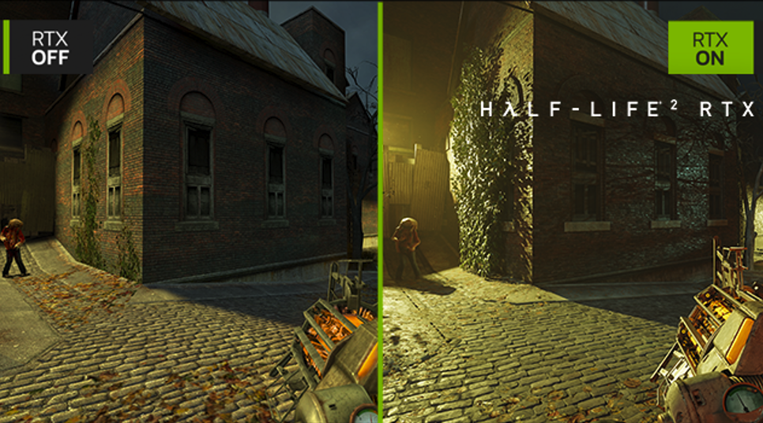
Tech Headline |  | FULL RAY TRACING WITH NEURAL RENDERING
Features Headline |  | GAME-CHANGING REALISM
Features Body |  | The NVIDIA Blackwell architecture unlocks the game-changing realism of full ray tracing. Experience cinematic quality visuals at unprecedented speed powered by GeForce RTX 50 Series with fourth-gen RT Cores and breakthrough neural rendering technologies accelerated with fifth-gen Tensor Cores.
Partner KSP 2.3
Image reference |  | 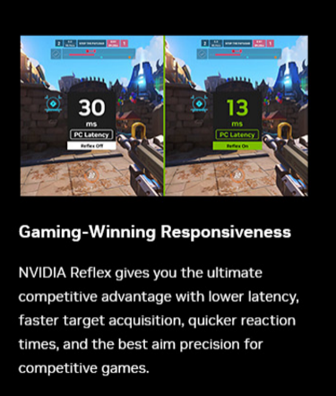
Tech Headline |  | NVIDIA REFLEX
Features Headline |  | GAME-WINNING RESPONSIVENESS
Features Body |  | NVIDIA Reflex gives you the ultimate competitive advantage with lower latency, faster target acquisition, quicker reaction times, and the best aim precision for competitive games.
Partner KSP 2.4
Image reference |  | 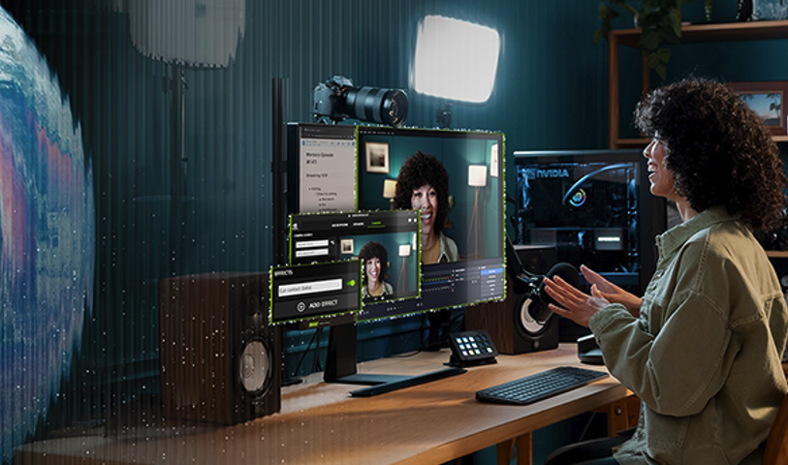
Tech Headline |  | RTX AI PC
Features Headline |  | NVIDIA POWERS THE  WORLD’S AI. AND YOURS.
Features Body |  | Upgrade to advanced AI with NVIDIA GeForce RTX™ GPUs and accelerate your gaming, creating, productivity, and development. Thanks to built-in AI processors, you get world-leading AI technology powering your Windows PC.
Partner KSP 2.5
Image reference |  | 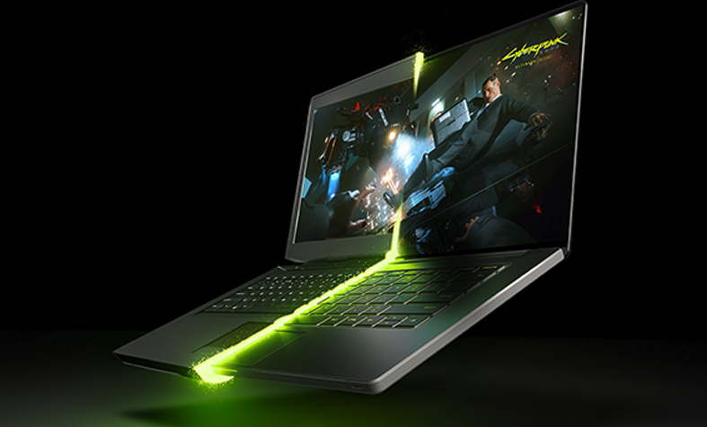
Tech Headline |  | NVIDIA BLACKWELL MAX-Q
Features Headline |  | OPTIMIZED POWER AND PERFORMANCE
Features Body |  | Max-Q is designed from the ground up for maximum efficiency, delivering a massive leap in performance and battery life.
Acer KSP 1
Image reference / suggestion |  | 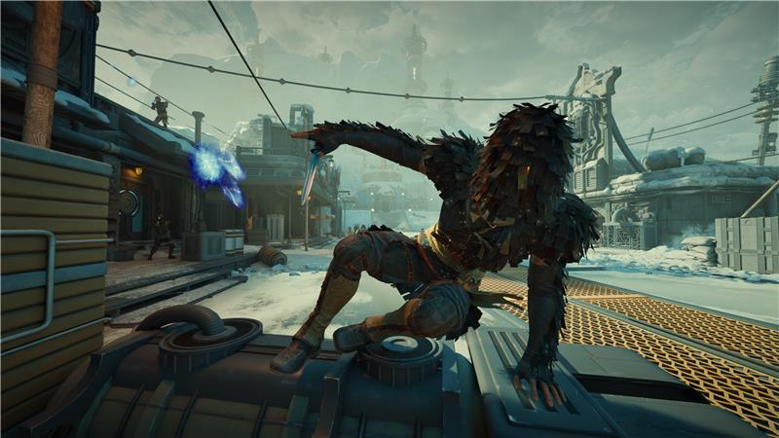  ADD CALMAN VERIFIED LOGO TO IMAGE
KSP Headline (40) |  | EXPERIENCE CINEMATIC HDR AT ITS BEST
KSP Body (220) |  | With up to an 18.0" Mini LED display that delivers stunning visuals with HDR brilliance and a peak brightness of 1000 nits, every scene comes to life, bringing deeper contrasts and sharper details.
Overline (20) |  | Up to 16:10 |  | Up to |  |  |  | True-to-Life Color |  |  | Up to
Spec (30) |  | MINI LED 4K |  | 120HZ / 3ms |  |  |  | CALMAN VERIFIED |  |  | 100% DCI-P3
Underline (20) |  | WQUXGA |  | Refresh / Response |  |  |  | Laptop Display |  |  | Wide Color Gamut
Acer KSP 1.1
Image Reference |  | 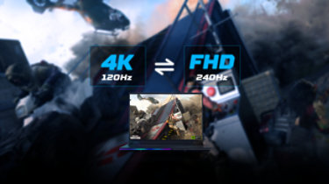
KSP Headline (40) |  | DUAL-MODE DISPLAY
KSP Body (180) |  | Switch seamlessly between 4K at 120Hz for sharp visuals or FHD at 240Hz for ultra-smooth gameplay. Tailor your display to your needs with a simple toggle, combining precision and performance in one screen.
Acer KSP 1.2
Image Reference |  | 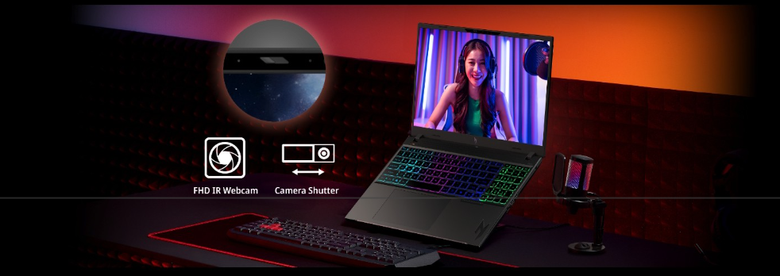  Make it predator themed  [Remove shutter logo]
KSP Headline (40) |  | SHARPER FOCUS
KSP Body (180) |  | The FHD IR camera delivers crisp, consistent image quality for streaming, squad coordination, and competitive play, keeping you visible and locked in when every call counts.
Acer KSP 3
KSP Headline (40) |  | CUSTOM-ENGINEERED COOLING THAT NEVER QUITS
KSP Body (220) |  | Two of the world’s thinnest 6th Gen AeroBlade 3D Fans use ultra-thin metal blades to boost airflow efficiency by up to 20%. Working with liquid metal thermal grease and vector heat pipes, the system maintains stable performance as demands intensify.
Overline (20) |  | World’s Thinnest 0.05 MM |  |  | 100 RAZOR-SHARP BLADES |  |  |  | 20% INCREASE |  |  |  | ADAPTIVE BLADES
Spec (30) |  | Fan Blades |  |  | Optimization |  |  |  | in Airflow |  |  |  | Dynamically Adjusting
Acer KSP 3.1
KSP Headline (40) |  | LIQUID METAL THERMAL GREASE
KSP Body (180) |  | Replaces traditional compounds to accelerate heat transfer from the CPU, reducing thermal resistance and helping sustain higher performance under continuous load.
Acer KSP 3.2
KSP Headline (40) |  | VECTOR HEAT PIPES
KSP Body (180) |  | Precision-routed to move heat rapidly away from critical components, distributing thermal load evenly to maintain stability during extended gaming and workloads.
Acer KSP 4
KSP Headline (40) |  | PRECISION BEYOND THE MECHANICAL
KSP Body (220) |  | Our unique, patented Predator MagKey 4.0 grant control with pinpoint precision. These next-gen mechanical switches activate through magnetic actuation, delivering keystrokes that are not only fast but meticulously accurate.
OVERLINE (20) |  | Eight Total Keys |  |  |  | Next-Gen Feedback |  |  |  | Precise Control
SPEC (40) |  | SWAPPABLE WASD & ARROW KEYS |  |  |  | TACTILE, MECHANICAL PRESS |  |  |  | 0.7MM ACTUATION
Acer KSP 5
KSP Headline (40) |  | SIX SPEAKER AUDIO IMMERSION
KSP Body (220) |  | Experience laptop audio like never before. Predator Vox is a patented speaker system built for high-fidelity nearfield audio which enhances directionality, clarity, and immersive range.
Acer KSP 5.1
KSP Headline (40) |  | PATENTED TUBE DESIGN
KSP Body (180) |  | Internal channels stabilize waveform output to reduce muddiness, keeping sound sharp and distortion-free at higher volumes.
Acer KSP 5.2
KSP Headline (40) |  | DEDICATED BASS AND TREBLE
KSP Body (180) |  | A 2-way speaker setup separates bass and treble frequencies for cleaner projection and richer, full-spectrum sound.
Acer KSP 5.3
KSP Headline (40) |  | WIDE AND CLEAR STAGE
KSP Body (180) |  | Covers more horizontal space than typical laptop speakers, helping you locate enemies and track movement with sharper directional audio.
Acer KSP 6
Image reference |  | 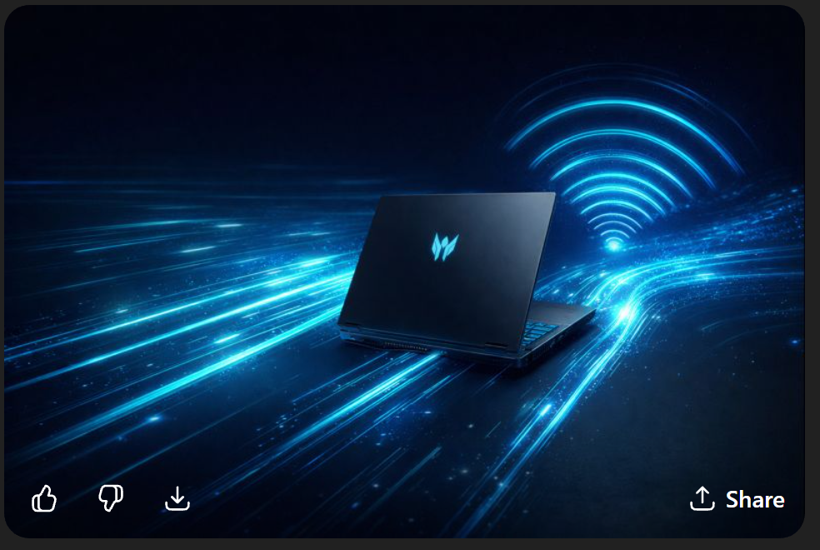  Ideal is to show speed, a wifi icon
KSP Headline (40) |  | UNBOUND SPEED AND CONNECTION
KSP Body (220) |  | Built for competitive play and high-bandwidth workflows, next-gen connectivity removes bottlenecks across gaming, streaming, and multi-display setups. Wired or wireless, latency stays low and data moves without hesitation.
Acer KSP 6.1
KSP Headline (40) |  | THUNDERBOLT™ 5 UNLEASHED
KSP Body (180) |  | Delivers up to 80 Gbps bidirectional bandwidth, with asymmetric boost up to 120 Gbps for display-heavy workflows, high-speed storage, and advanced multi-device setups.
Acer KSP 6.2
KSP Headline (40) |  | WI-FI 7, NO COMPROMISE
KSP Body (180) |  | Intel® Killer™ 1750X Wi-Fi 7 unlocks wider channels and improved congestion handling, delivering faster wireless throughput and smoother play in crowded network environments.
Acer KSP 6.3
KSP Headline (40) |  | ETHERNET THAT KEEPS YOU ENGAGED
KSP Body (180) |  | Intel® Killer™ Ethernet E5000B delivers deterministic, low-latency wired performance for competitive play where consistency and packet control matter most.
Acer KSP 6.4
KSP Headline (40) |  | INTELLIGENT TRAFFIC CONTROL
KSP Body (180) |  | Killer™ DoubleShot™ Pro prioritizes game traffic across wired and wireless connections, reducing interruptions and keeping latency consistent when multiple apps and downloads compete for bandwidth.
Acer KSP 7
KSP Headline (40) |  | COMMAND THE LIGHT
KSP Body (220) |  | Lighting is more than visual flair. Every zone, key, and contour responds with purpose, reinforcing presence, control, and identity across your setup. Illumination becomes part of how the system moves, reacts, and commands attention.
Image for BELOW
OVERLINE (20) |  | Rear Lighting |  |  | Brand Signature |  |  |  | Input Precision |  |  |  | Chassis Accent
SPEC (40) |  | MILKYWAY RGB DYNAMIC LIGHTING |  |  | ILLUMINATED PREDATOR LOGO |  |  |  | PER-KEY RGB KEYBOARD LIGHTING |  |  |  | L-SHAPE & PALM REST LIGHTING
Acer KSP 8
KSP Headline (40) |  | PREDATORSENSE
KSP Body (180) |  | Real-time command of fan curves, performance modes and system vitals, giving you tight, stable gameplay exactly when the pressure rises.
Acer KSP 8.2
KSP Headline (40) |  | ACER MY KEY
KSP Body (180) |  | Assign instant shortcuts to tools, apps or system actions through a single press, cutting out delays and keeping your setup ready for anything.
Acer KSP 8.3
KSP Headline (40) |  | ACER INTELLIGENCE SPACE
KSP Body (220) |  | Launch smarter performance through Acer Intelligence Space, your hub for AI-ready tools and hardware insights that fuel productivity, creativity, and gaming
CURRENT MS PARTNER KSP (EOD 4/1/26)
KSP Headline (40) |  | DISCOVER YOUR NEXT FAVORITE GAME
KSP Body (220) |  | Play hundreds of PC games with your new Predator Windows 11 PC and three months of PC Game Pass, including EA Play. With new games added all the time, there’s always something new to play.
Go Live April 1st, 2026
(ONLY USE ONE GAME PASS KSP)
NEW MS PARTNER KSP (US)
KSP Headline |  | DISCOVER YOUR NEXT FAVORITE GAME WITH 2 MONTHS OF XBOX GAME PASS
KSP Body |  | Play Forza Horizon 5 and 200+ more games on your new Predator Windows 11 PC with 2 months of Xbox Game Pass Premium. New Xbox published games join the library within 1 year of launch. Dive into a range of legendary franchises from Call of Duty to Minecraft and everything in between. Get in-game benefits for the biggest games like League of Legends, Call of Duty: Warzone, Rainbow Six Siege, and more. Play and earn up to $50 a year in the Store with Rewards. Find your community with Xbox and play anywhere you want
(ONLY USE ONE GAME PASS KSP)
NEW MS PARTNER KSP (WW)
KSP Headline |  | DISCOVER YOUR NEXT FAVORITE GAME WITH 2 MONTHS OF XBOX GAME PASS
KSP Body |  | Play Forza Horizon 5, and 200+ more games on your Predator Windows 11 PC with 2 months of Xbox Game Pass Premium. New Xbox published games join the library within 1 year of launch. Explore a range of global franchises from Minecraft to Halo and everything in between. Get in-game benefits for the biggest games like League of Legends, Call of Duty: Warzone, and Rainbow Six Siege, and more. Play and earn up to 50,000 points per year with Rewards. Find your community with Xbox and play anywhere you want.
Disclaimers
 | This product is not designed for cryptocurrency mining uses. Damages to your product arising from cryptocurrency mining or related activities are excluded from your product’s warranty.
 | The terms HDMI and HDMI High-Definition Multimedia Interface and the HDMI Logo are trademarks or registered trademarks of HDMI Licensing Administrator, Inc. in the United States and other countries.
 | Specifications may vary depending on model and/or region. All models subject to availability.
Intel® technologies’ features and benefits depend on system configuration and may require enabled hardware, software, or service activation. Performance varies depending on system configuration. No product or component can be absolutely secure.

© Intel Corporation. Intel, the Intel logo, and other Intel marks are trademarks of Intel Corporation or its subsidiaries. Other names and brands may be claimed as the property of others.
 | ©2026 NVIDIA Corporation. NVIDIA, the NVIDIA logo, GeForce, and GeForce RTX are registered trademarks and/or trademarks of NVIDIA Corporation in the United States and other countries. All other trademarks and copyrights are the property of their respective owners.
 | Depending on the region, this laptop may be bundled with a mouse. In such case, the mouse may not support NVIDIA Reflex functionality. Acer does not claim or guarantee compatibility of the bundled mouse with this feature.
 | Memory limits depend on the OS. For details on Windows 11 Home and other versions, visit Microsoft Learn: https://learn.microsoft.com/en-us/windows/win32/memory/memory-limits-for-windows-releases.
 | Features and availability of Acer Intelligence Space (AIS) vary by model and region. Some functions require an active internet connection, supported hardware (such as an NPU or specific GPU), and future software updates. Performance may vary depending on system configuration
 | With support for 3:1 display stream compression.
 | Dual-mode technology only available on models with GeForce RTX™ 5090 laptop GPU.
 | Laptop charging: Thunderbolt™ 4 technology for thin and light notebooks that require up to 100W to charge. Thunderbolt™ 5 technology for laptops that require up to 140W to charge. 140W‒240W is available on some devices.
Results measured in CFM using synthetic modeling. Actual performance and design may vary depending on model. Testing completed using similar fan size while maintaining equal dB levels

Plastic fan based on generic model.
 | Based on Acer's internal research as of Aug, 2025. Claim refers to the thinnest cooling fan blade for laptops, measuring 0.05mm. Patent pending/held by Acer Inc
Current XGP - Use until 4/1/26
 | PC Game Pass: Subscription continues automatically at regular monthly price unless cancelled. Subject to xbox.com/subscriptionterms. Terms and exclusions apply. Game catalog varies over time, by region, and by device. All rights reserved. xbox.com/pcgamepass, ea.com/ea-play/terms. (above disclaimer is from the FY25 Xbox marketing guideline for your reference)
New Disclaimer for Xbox GP - Go live 4/1/26
 | Claim within 30 days of device activation. New and eligible returning members only. Valid payment method required. Subscription continues automatically at regular monthly price unless cancelled. Subject to xbox.com/subscriptionterms. New Call of Duty titles will join the library at least 12 months after launch. Benefits vary by Xbox Game Pass plan. Game library varies over time, by region, device, and Xbox Game Pass plan. xbox.com/gamepass. In-game benefits vary by game, region, and over time. Game must be installed to access in-game benefits. Xbox Cloud Gaming requires an Xbox Game Pass subscription and supported device (both sold separately). Cloud playable games not included with Xbox Game Pass are sold separately, and may be made available with Xbox Game Pass in the future. See library: xbox.com/play. Stream directly on Xbox consoles, or with the Xbox app or at xbox.com/play on supported devices. Select regions (xbox.com/regions) and devices (xbox.com/cloud-devices). Rewards: Terms apply. Microsoft Account required. Select markets only. Rewards vary by Game Pass Plan and Rewards Level. Point values vary by local market currency, Rewards level, and the number of points redeemed. Point multipliers compared to Game Pass Essential earning potential. Gameplay rewards for 18+. Exclusive quests with Premium and Ultimate plans only, for titles in the Game Pass library. Qualifying purchases at Microsoft Store (online, or on Windows or console) at Rewards with Xbox.

